**Why doesn’t power change across sampling designs?**

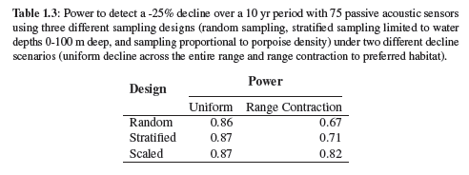

**Random**

* The mean PPS of this iteration was 168

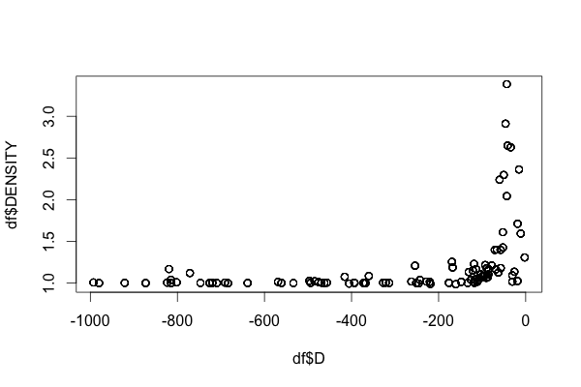

Fig. 1: Depth vs. predicted density for a random design

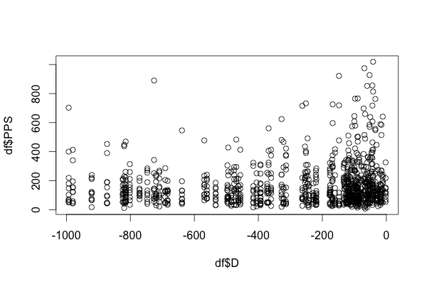

Fig. 2: Depth vs. PPS for a random design

**Stratified (in depths 0 to 100 m deep) design**

* The mean PPS of this iteration was 210

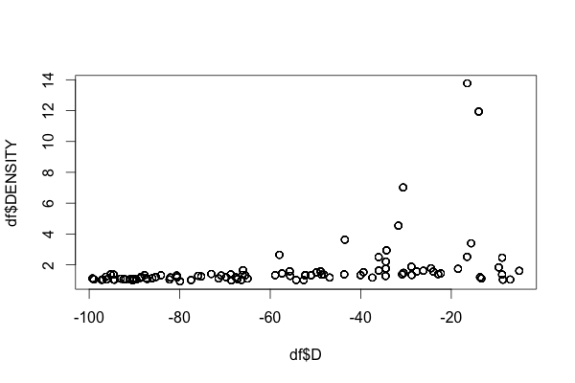

Fig. 1: Depth vs. predicted density (from GAM) at locations 0-100 m deep

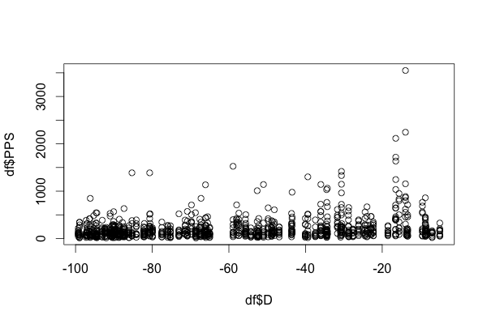

Fig. 2: Depth vs. simulated PPS at locations 0-100 m deep